Signature

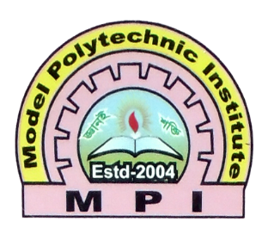

**Remarks**

**Assignment Report**

|  |  |
| --- | --- |
| Subject Name | **:** PCB Design and Circuit Making |
| Subject Code | **:** 66655 |
| Expt. / Job No | **:** 01 |
| Name of the Expt. / Job | **:** 230 volt AC to 5 volt dc converter with using Proteus software. |
| Date of the Expt. / Job | **:** 08-06-2022 |
| Date of the Sub. / Job | **:** 15-06-2022 |

|  |  |  |  |
| --- | --- | --- | --- |
| **Submitted By:** | | **Submitted To:** | |
| Name | : Md. Jahid Hossain | Name | : Mominur Rohman |
| Department | : Computer | Lecturer | **:** EEE |
| Board Roll | : 434575 |  |  |
| Semester | : 5th |  |  |
| Session | : 2019-2020 |  |  |

**MODEL POLYTECHNIC INSTITUTE, JASHORE**